A Project Report
on

"Predicting Mental Health Risk Based on Social Media Usage Patterns"

submitted to the
Department of Statistics

For the partial fulfilment of the requirements for the award of the degree of
Master of Science (Data Science)

By
MUSKAN SAXENA
Roll No.: 2409196900002
Enrolment No.: AU24134487385

Under the Supervision of
DR. RANJANA GUPTA
AND
DR. MINAKSHI PACHAURI
Lecturer, Deptt. of Statistics



INSTITUTE OF SOCIAL SCIENCES
DR. BHIMRAO AMBEDKAR UNIVERSITY
PALIWAL PARK, AGRA – 282004
May 2026

DECLARATION

I hereby declare that the project titled “Predicting Mental Health Risk Based on Social Media Usage Patterns” is an original work carried out by me as part of the requirements for the award of the degree of Master of Science (M.Sc) in Data Science, 4th Semester.
This project has been completed under proper guidance and supervision, and all the work presented in this report is my own. I confirm that this work has not been submitted previously, in part or in full, for the award of any degree, diploma, or other academic qualification to this or any other institution.
I have duly acknowledged all sources of information used in this project. Any assistance received during the course of this work has also been properly credited.
Name: Muskan
Course: M.Sc Data Science
Semester: 4th Semester
Roll Number: 2409196900002
Enrollment No: AU24134487385
Date: ___________
Place: ___________
Signature of Student: ____________________

CERTIFICATE

This is to certify that the project titled “Predicting Mental Health Risk Based on Social Media Usage Patterns” submitted by Muskan, a student of M. Sc Data Science (4th Semester), is a bona fide record of work carried out by her under my supervision and guidance.
This project has been completed in partial fulfilment of the requirements for the award of the degree of Master of Science (M. Sc) in Data Science. The work presented in this project report is original and has not been submitted elsewhere for any other degree or diploma. To the best of my knowledge, this work is worthy of consideration for the award of the degree.
Guide Name: __________________________
Designation: __________________________
Department: __________________________
Institution: __________________________
Date: ___________
Place: ___________
Signature of Guide: ____________________
Head of Department
Signature: ____________________

ACKNOWLEDGEMENT

I would like to express my sincere gratitude to my project guide,
__________________________, for their continuous support, valuable guidance, and encouragement throughout the completion of this project titled “Predicting Mental Health Risk Based on Social Media Usage Patterns”. Their insights and suggestions greatly contributed to the successful completion of this work.
I am also thankful to the Head of the Department and all the faculty members of the Data Science department for providing the necessary resources, knowledge, and support required for this project.
I would like to extend my heartfelt thanks to my friends and classmates for their cooperation and constructive discussions, which helped me in improving my understanding of the subject.
Finally, I am deeply grateful to my family for their constant motivation, support, and encouragement, which helped me complete this project successfully.
Name: Muskan
Course: M.Sc Data Science
Semester: 4th Semester
Date: ___________
Place: ___________
Signature: ____________________

PREFACE

The field of data science has emerged as a powerful tool for analyzing complex real-world problems and extracting meaningful insights from data. In recent years, the rapid growth of social media has significantly influenced human behavior and lifestyle, raising important concerns regarding its impact on mental health. This project, titled “Predicting Mental Health Risk Based on Social Media Usage Patterns”, is an attempt to explore and analyze this relationship using data-driven techniques.
The primary objective of this project is to understand how various patterns of social media usage, such as time spent, behavioral tendencies, and psychological responses, contribute to mental health outcomes. By applying statistical analysis, machine learning models, and clustering techniques, this study aims to predict mental health risk levels and identify key factors influencing them.
This project has been carried out as part of the Master of Science (M.Sc) in Data Science, 4th Semester curriculum. It provided an opportunity to apply theoretical concepts to practical scenarios, enhancing both technical skills and analytical thinking. The integration of feature engineering, exploratory data analysis, and model evaluation has contributed to a comprehensive understanding of predictive modeling in the domain of mental health.
I hope that this project will serve as a meaningful contribution towards understanding the impact of digital behavior on psychological well-being and encourage further research in this important area.
Name: Muskan Saxena
Course: M. Sc Data Science
Semester: 4th Semester
Date: ___________
Place: ___________

ABSTRACT

In the digital era, social media has become an integral part of daily life, significantly influencing human behaviour and psychological well-being. While it offers connectivity and information sharing, excessive and unregulated usage has been associated with adverse mental health outcomes such as anxiety, depression, and sleep disturbances. This project aims to analyse the relationship between social media usage patterns and mental health, and to develop a predictive model for assessing mental health risk.
The study utilizes a survey-based dataset comprising demographic information, social media usage behaviour, and psychological indicators. Data preprocessing techniques were applied to clean and transform the dataset, followed by feature engineering to derive meaningful variables such as addiction score, behavioural score, and mental score. A combined mental health index was constructed using depression, anxiety, and sleep-related factors, which was further categorized into Low, Medium, and High risk level.
Exploratory Data Analysis (EDA) was conducted to identify patterns and correlations between usage behaviour and mental health outcomes. Clustering techniques, including K-Means and Hierarchical Clustering, were applied to segment users based on behavioural characteristics. Multiple machine learning models, such as Logistic Regression, Decision Tree, Random Forest, Support Vector Machine, and Gradient Boosting, were implemented and evaluated using accuracy and cross-validation techniques.
The results indicate that behavioural factors such as excessive usage, social comparison, and validation-seeking significantly contribute to higher mental health risk. Among the models, ensemble methods demonstrated superior performance in capturing complex patterns within the data. Additionally, a live prediction system was developed to demonstrate real-time applicability of the model.
This study highlights the importance of responsible social media usage and demonstrates the potential of data science techniques in predicting and analysing mental health risks.

INTRODUCTION

In recent years, social media has become an essential part of everyday life, transforming the way individuals communicate, interact, and consume information. Platforms such as Instagram, Facebook, and YouTube have significantly increased user engagement, leading to extended screen time and continuous online presence. While social media provides numerous benefits, including connectivity and access to information, its excessive usage has raised serious concerns regarding its impact on mental health.
Several studies have suggested that prolonged exposure to social media can contribute to psychological issues such as anxiety, depression, sleep disturbances, and reduced attention span. Behavioral patterns such as frequent comparison with others, seeking validation through likes and comments, and mindless scrolling are increasingly linked to negative emotional outcomes. These factors highlight the need for a systematic analysis of how social media usage influences mental well-being.
With the advancement of data science and machine learning techniques, it is now possible to analyse large datasets and identify patterns that are not easily observable through traditional methods. Predictive modelling enables the identification of individuals at risk by analysing behavioural and psychological indicators.
The primary aim of this project is to analyse social media usage patterns and predict mental health risk using data-driven approaches. A comprehensive methodology has been adopted, including data preprocessing, feature engineering, exploratory data analysis, clustering, and the application of multiple machine learning models. A combined mental health index has been developed to provide a holistic measure of psychological well-being, which is further used to classify individuals into different risk categories.
This study not only contributes to understanding the relationship between digital behaviour and mental health but also demonstrates the practical application of data science in addressing real-world problems.

LITERATURE REVIEW

The relationship between social media usage and mental health has been a subject of increasing interest among researchers in recent years. With the rapid growth of digital platforms, several studies have examined how excessive usage influences psychological well-being, particularly among young adults and adolescents.
Keles, McCrae, and Grealish (2020) conducted a systematic review and found a significant association between social media use and mental health problems such as depression, anxiety, and psychological distress. The study emphasized that prolonged exposure to social media content can negatively affect emotional stability and self-esteem. Similarly, Primack et al. (2017) reported that individuals who spend more time on social media platforms are more likely to experience perceived social isolation, which is a key factor contributing to depression.
Further research by Lin et al. (2016) highlighted that higher frequency of social media usage is strongly correlated with increased levels of anxiety and sleep disturbances. The study also suggested that behavioral factors such as constant comparison with others and the need for validation through likes and comments contribute significantly to mental stress.
In addition to behavioral studies, the application of data science and machine learning in mental health prediction has gained attention. Researchers have utilized classification algorithms such as Logistic Regression, Decision Trees, and Random Forests to predict mental health conditions based on survey data and behavioral patterns. These models have demonstrated effectiveness in identifying individuals at risk and providing early intervention insights.
Moreover, clustering techniques like K-Means have been employed to segment users into distinct groups based on their social media behavior. This approach helps in identifying different user profiles, such as low-risk users with moderate usage and high-risk users with excessive engagement and behavioral dependency.

OBJECTIVES

The primary objective of this project is to analyze the impact of social media usage patterns on mental health and to develop a predictive model for assessing mental health risk. The specific objectives of the study are as follows:
- To study and analyze various social media usage behaviors, including time spent, purposeless usage, distraction, and interaction patterns.
- To identify key behavioral and psychological factors that influence mental health, such as social comparison, validation seeking, anxiety, depression, and sleep disturbances.
- To perform data preprocessing and transformation to prepare the dataset for analysis and modeling.
- To develop new features, such as addiction score, behavioral score, and mental score, in order to capture complex relationships within the data.
- To construct a combined mental health index using multiple psychological indicators and categorize it into different risk levels.
- To conduct exploratory data analysis (EDA) to identify trends, patterns, and correlations between social media usage and mental health.
- To apply clustering techniques for grouping users based on their behavioral patterns and usage characteristics.
- To build and compare multiple machine learning models for predicting mental health risk.
- To evaluate model performance using appropriate metrics and select the most accurate and reliable model.
- To develop a real-time prediction system that can estimate mental health risk based on user inputs.

DATASET DESCRIPTION

The dataset used in this study is a survey-based dataset that captures information related to social media usage patterns and mental health indicators. It consists of responses collected from individuals belonging to different age groups, primarily focusing on young adults who are active users of social media platforms.
The dataset contains a total of 447 observations and multiple variables representing demographic details, behavioural patterns, and psychological factors. The key attributes include age, gender, relationship status, occupation, type of organization, and commonly used social media platforms. In addition to demographic variables, the dataset includes several behavioural indicators such as average daily time spent on social media, purposeless usage, level of distraction, restlessness, and validation-seeking behaviour.
Furthermore, the dataset incorporates psychological measures, including levels of anxiety, depression, sleep disturbances, concentration difficulties, and fluctuations in daily activities. Most of these variables are measured on a Likert scale ranging from 1 to 5, where higher values indicate a greater intensity of the respective behaviour or condition.
For the purpose of analysis, the dataset was pre-processed to remove inconsistencies and missing values, and categorical variables were converted into numerical form. New features such as addiction score, behavioural score, and mental score were derived to better represent user behaviour. Additionally, a combined mental health index was created using depression, anxiety, and sleep-related variables, which was further categorized into Low, Medium, and Highrisk levels.
This dataset provides a comprehensive view of how social media usage and behavioral patterns are associated with mental health, making it suitable for both exploratory analysis and predictive modelling.

METHODOLOGY

The methodology adopted in this study follows a systematic data science pipeline to analyse social media usage patterns and predict mental health risk. The process consists of multiple stages, including data pre-processing, feature engineering, target variable creation, exploratory data analysis, clustering, and machine learning model development. Initially, the dataset was collected in the form of survey responses containing demographic, behavioural, and psychological variables. The first step involved data pre-processing, where the dataset was cleaned by handling missing values, standardizing column names, and removing irrelevant or inconsistent entries. Categorical variables were transformed into numerical form to make the data suitable for machine learning algorithms.
In the next stage, feature engineering was performed to derive meaningful variables from the existing data. New features such as addiction score, behavioral score, and mental score were created by combining related variables. These features helped in capturing underlying behavioural patterns and improving the predictive capability of the models.
Subsequently, a combined mental health index was constructed using key psychological indicators, namely depression, anxiety, and sleep-related issues. This index provided a comprehensive representation of an individual’s mental health status. The index was further categorized into three levels: Low, Medium, and High risk, which served as the target variable for classification.
Exploratory Data Analysis (EDA) was then conducted to understand the distribution of variables and identify relationships between social media usage and mental health. Various visualizations such as histograms, box plots, scatter plots, and correlation heatmaps were used to extract meaningful insights from the data.
To further enhance the analysis, clustering techniques such as K-Means and Hierarchical Clustering were applied. These techniques grouped users into distinct clusters based on their behaviour and usage patterns, helping to identify different user segments and their corresponding risk levels.
Following this, multiple machine learning models were developed, including Logistic Regression, Decision Tree, Random Forest, Support Vector Machine, and Gradient Boosting. The dataset was divided into training and testing sets, and the models were trained to predict mental health risk. Model performance was evaluated using accuracy, confusion matrix, and cross-validation techniques. Finally, a live prediction system was implemented to demonstrate the practical applicability of the model. This system allows users to input their behavioural data and obtain a predicted mental health risk level in real time.

DATA PREPROCESSING

Data pre-processing is a crucial step in any data science project, as it ensures that the dataset is clean, consistent, and suitable for analysis and modelling. In this study, several pre-processing techniques were applied to transform the raw survey data into a structured format.
Initially, the dataset was loaded and examined to understand its structure, including the number of observations, variables, and data types. Column names were standardized by converting them into lowercase and replacing spaces with underscores to improve readability and ease of handling.
Missing values and inconsistent entries were identified and handled appropriately. Rows containing invalid or incomplete data were removed to maintain data quality. The age variable was converted into numeric format, and unrealistic values were filtered to ensure that only valid age ranges were retained.
The dataset contained several categorical variables, such as gender, occupation, and social media platforms. These variables were converted into numerical form using label encoding, enabling their use in machine learning algorithms. Additionally, survey responses measured on a Likert scale (e.g., “Never”, “Sometimes”, “Often”) were mapped to numerical values ranging from 1 to 5, ensuring uniformity across the dataset.
The variable representing daily social media usage was also transformed into a numeric format by extracting values from categorical ranges (e.g., “1–2 hours” converted to numerical form). This allowed for quantitative analysis of usage patterns.
Irrelevant or redundant columns were removed to reduce noise in the dataset. Furthermore, care was taken to avoid data leakage by excluding variables such as depression, anxiety, and sleep issues from the feature set when they were used to construct the target variable.
After completing these pre-processing steps, the dataset was transformed into a clean and structured format, making it suitable for further analysis, feature engineering, and machine learning modelling.

FEATURE ENGINEERING

Feature engineering is the process of creating new variables from existing data to improve the performance and interpretability of machine learning models. In this study, several meaningful features were derived to capture complex behavioural and psychological patterns associated with social media usage.
The raw dataset consisted of multiple survey-based variables representing different aspects of user behaviour and mental health. To enhance the analytical value of the dataset, related variables were combined to form composite features.
Firstly, an addiction score was created to measure the level of social media dependency. This score was computed by taking the average of variables such as purposeless usage, level of distraction, restlessness, and validation-seeking behavior. These factors collectively represent addictive patterns associated with excessive social media use.
Secondly, a behavioural score was developed based on variables related to social comparison and emotional response to such comparisons. This feature reflects how individuals perceive themselves in relation to others on social media and the psychological impact of these comparisons.
Thirdly, a mental score was constructed using indicators such as concentration difficulties, sleep disturbances, and fluctuations in daily activities. This score provides insight into the cognitive and emotional state of individuals.
In addition, an overall score was calculated by combining the addiction score, behavioral score, and mental score. This composite feature offers a holistic view of the user’s behavior and mental condition.
All derived features were computed using the mean of their respective components and were rounded for consistency and interpretability. These engineered features helped in reducing dimensionality, improving model performance, and capturing underlying relationships within the data.
Overall, feature engineering played a significant role in transforming raw survey responses into meaningful variables that better represent real-world behavioral and psychological patterns.

TARGET VARIABLE

In this study, the target variable represents the mental health risk level of individuals, which the machine learning models aim to predict. Instead of relying on a single psychological factor, a more comprehensive approach was adopted by constructing a combined mental health index.
The mental health index was developed using three key psychological indicators: depression, anxiety, and sleep-related issues. These variables were selected because they are widely recognized as important components of mental well-being. The index was calculated by taking the average of these three variables, thereby providing a holistic measure of an individual’s mental health condition.
Once the mental health index was computed, it was transformed into a categorical variable to facilitate classification. The index values were divided into three distinct categories:
- Low Risk (values less than or equal to 2)
- Medium Risk (values between 2 and 3)
- High Risk (values greater than 3)
This categorization enabled the formulation of the problem as a supervised classification task, where the objective is to predict the risk category based on user behavior and usage patterns.
It is important to note that the variables used to construct the mental health index, namely depression, anxiety, and sleep issues, were excluded from the feature set during model training. This was done to prevent data leakage, ensuring that the model does not gain unfair advantage by using information directly related to the target variable.
The creation of a combined mental health index provides a more robust and realistic representation of psychological well-being compared to using individual variables, thereby improving the reliability and interpretability of the predictive model.

EXPLORATORY DATA ANALYSIS
EDA Chart 1: Age Distribution
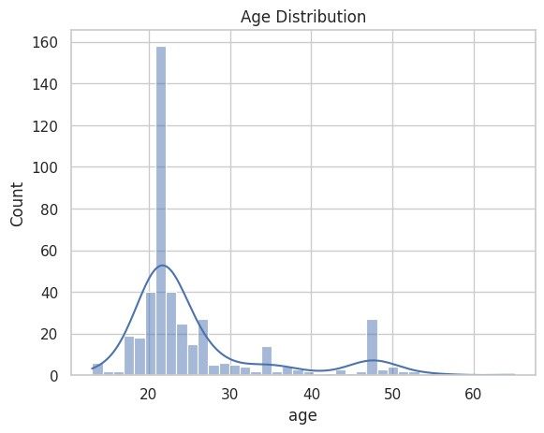
What the Chart Shows?
This histogram represents the distribution of participants’ ages in the dataset, along with a density curve showing the overall trend.

Key Insight
The dataset is heavily concentrated in the young adult age group, with the majority of respondents falling between 18 and 25 years.

Interpretation
● The peak around age ~20–22 shows that most users are students or young adults ● Very few participants are above 40+, indicating limited representation of older age groups ● The distribution is right-skewed, meaning:
○ More young users
○ Fewer older users

Why This Matters
Since the dataset is dominated by young individuals, the results of this study are more reflective of the mental health patterns of young social media users.

EDA Chart 2: Gender vs Mental Health Risk
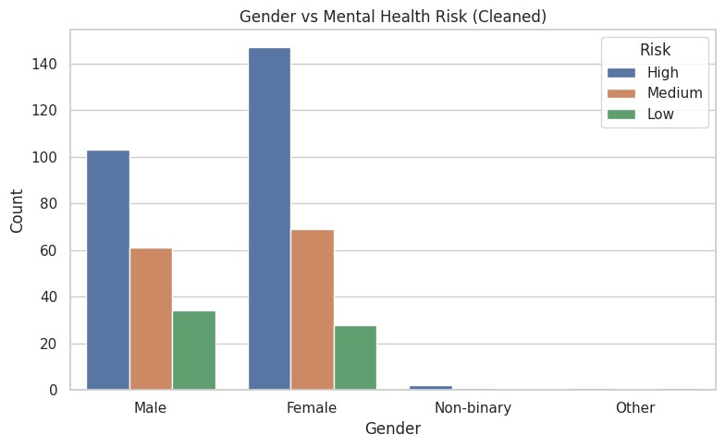

What the Chart Shows
This bar chart compares the distribution of mental health risk levels (Low, Medium, High) across different gender categories.

Key Insight
Female participants show a higher count in the high-risk category compared to male participants, indicating a relatively greater mental health risk among females in the dataset.

Interpretation
- Both male and female groups have a significant number of individuals in the high-risk category
- However, females have noticeably higher counts in high risk
- Medium risk is also slightly higher among females
- Low-risk individuals are fewer in both groups Non-binary and other categories:
- Very few data points
- Cannot draw strong conclusions

Why This Matters
The results suggest that gender may play a role in mental health outcomes related to social media usage, although further analysis is required due to sample imbalance

EDA 3-Social Media Usage vs Mental Health Risk
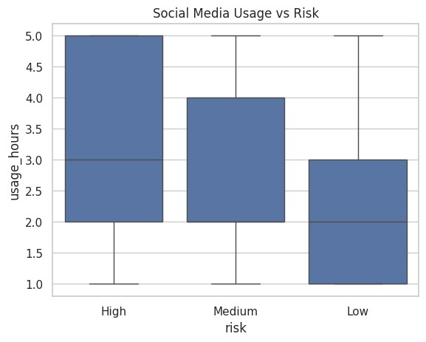

1. What the Chart Shows
This boxplot illustrates the relationship between daily social media usage (in hours) and different mental health risk levels (Low, Medium, High).
2. Key Insight
Individuals in the high-risk category tend to have higher social media usage compared to those in medium and low-risk categories.

3. Interpretation
● High-risk group:
○ Higher median usage (~3 hours or more) ○ Wider spread → more variability in usage ● Medium-risk group:
○ Moderate usage levels ○ Lies between high and low ● Low-risk group:
○ Lower median usage (~2 hours)
○ Less variability
Overall trend:
As usage increases → risk level increases

4. Why This Matters
The plot suggests a positive association between time spent on social media and mental health risk, supporting the hypothesis that excessive usage may negatively impact psychological well-being.

EDA 4: Addiction Score vs Mental Health Risk
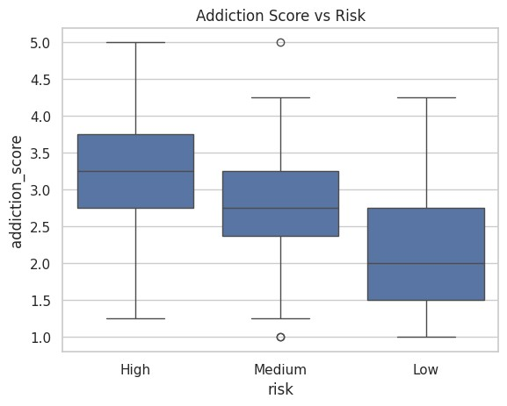

1. What the Chart Shows
This boxplot shows the relationship between the addiction score and different mental health risk levels (Low, Medium, High). The addiction score represents the level of social media dependency based on user behavior.

2. Key Insight
Higher addiction scores are associated with higher mental health risk, indicating a strong link between addictive behavior and psychological well-being.

3. Interpretation
High-risk group:
Shows the highest median addiction score with a wider spread, indicating strong and variable addictive behavior.
Medium-risk group:
Displays moderate addiction levels with some variation and outliers.
Low-risk group:
Has the lowest addiction scores with more consistent behavior.
Overall trend:
As addiction score increases → mental health risk increases

4. Why This Matters
This suggests that excessive and addictive social media usage is an important factor contributing to higher mental health risk, validating the relevance of the addiction score in the analysis.

EDA 5: Sleep Issues vs Mental Health Risk
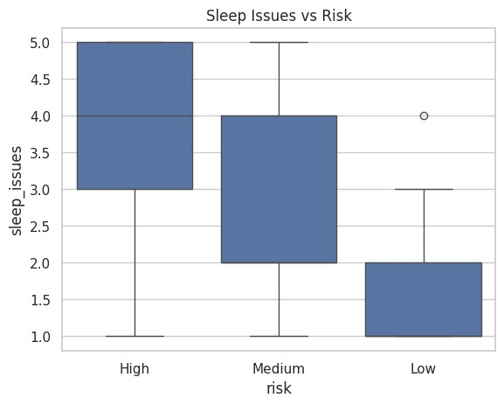

1. What the Chart Shows
This boxplot illustrates the relationship between sleep issues and different mental health risk levels (Low, Medium, High).

2. Key Insight
Individuals in the high-risk category tend to experience more sleep-related issues compared to those in medium and low-risk groups.

3. Interpretation
High-risk group:
Shows the highest median sleep issues score with a wider spread, indicating frequent and varied sleep disturbances.
Medium-risk group:
Displays moderate sleep issues with some variability.
Low-risk group:
Has the lowest sleep issue scores with more consistent and stable patterns.
Overall trend:
As sleep issues increase → mental health risk increases

4. Why This Matters
This suggests that poor sleep patterns are strongly associated with higher mental health risk, highlighting sleep as an important factor in psychological well-being.

EDA Chart 6: Correlation Heatmap
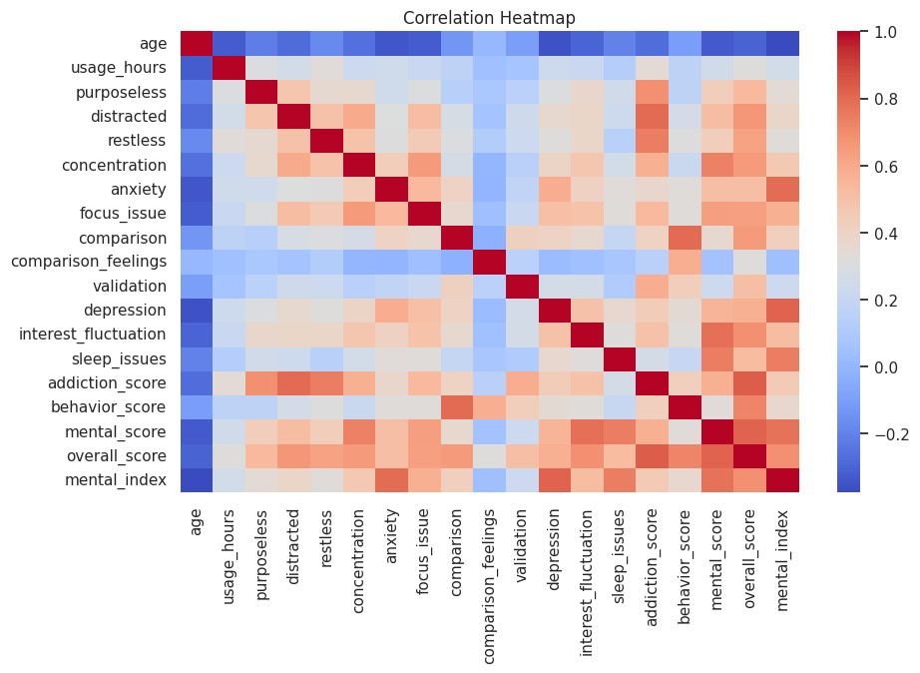

1. What the Chart Shows
This heatmap displays the correlation between different variables in the dataset, indicating how strongly they are related to each other. Warmer colors represent positive correlation, while cooler colors indicate negative or weak relationships.

2. Key Insight
Strong positive correlations are observed between behavioral factors (such as addiction score, purposeless usage, and distraction) and mental health indicators, suggesting that increased social media engagement is associated with higher mental health risk.

3. Interpretation
Behavioral variables:
Variables like purposeless usage, distraction, restlessness, and addiction score show strong positive correlations with each other, indicating interconnected addictive behavior patterns.
Mental health variables:
Depression, anxiety, sleep issues, and mental score are strongly correlated, suggesting they collectively represent psychological well-being.
Combined features:
Overall score and mental index show high correlation with most behavioral and mental variables, confirming their effectiveness as composite indicators.
Weak/negative relationships:
Age shows weak or negative correlation with most variables, indicating limited influence on mental health risk in this dataset.
Overall trend:
Higher behavioral engagement → stronger association with mental health issues

4. Why This Matters
The heatmap validates the relationships between variables and supports the effectiveness of feature engineering, showing that both behavioral and psychological factors play a significant role in predicting mental health risk.

EDA Chart 7: Comparison Behavior vs Mental Health
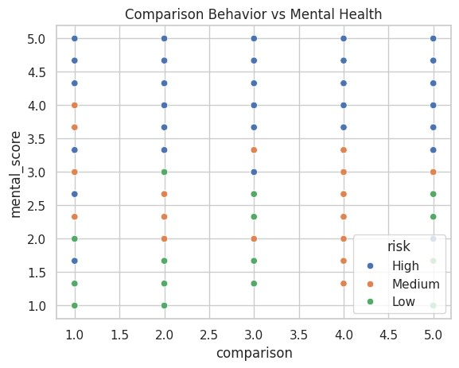

1. What the Chart Shows
This scatter plot shows the relationship between comparison behavior (how often individuals compare themselves to others on social media) and mental health score, with points categorized by risk levels (Low, Medium, High).

2. Key Insight
Higher levels of comparison behavior are associated with higher mental health risk, indicating that frequent social comparison negatively impacts psychological well-being.

3. Interpretation
High-risk group:
Individuals with higher comparison values tend to have higher mental scores, indicating greater psychological distress.
Medium-risk group:
Shows moderate comparison behavior with corresponding moderate mental health scores.
Low-risk group:
Displays lower comparison values and lower mental scores, indicating better mental well-being.
Overall trend:
As comparison behavior increases → mental health issues increase

4. Why This Matters
This highlights that social comparison is a significant psychological factor influencing mental health, suggesting that individuals who frequently compare themselves with others on social media are more likely to experience higher mental health risk.

EDA Chart 8 : Top Social Media Platforms
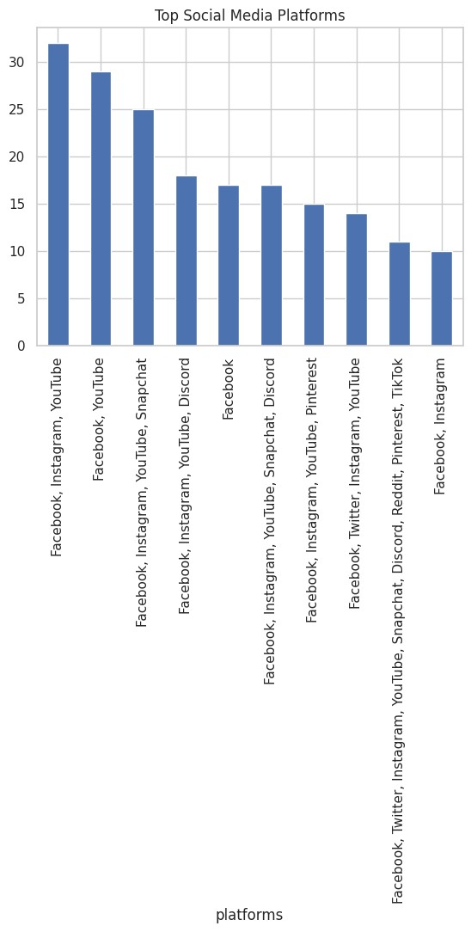

1. What the Chart Shows
This bar chart represents the most commonly used social media platforms among the participants, based on frequency of responses.

2. Key Insight
Platforms such as YouTube, Instagram, and Facebook appear most frequently, indicating that these are the dominant platforms among users in the dataset.

3. Interpretation
High-frequency platforms:
Combinations including YouTube, Instagram, and Facebook have the highest counts, showing that users are active on multiple major platforms simultaneously.
Moderate-frequency platforms:
Platforms like Snapchat, Discord, and Facebook appear moderately, indicating varied user preferences.
Low-frequency platforms:
Platforms such as TikTok, Reddit, Pinterest, and Twitter have lower counts, suggesting comparatively less usage among participants.
Overall trend:
Users tend to engage with multiple social media platforms rather than relying on a single platform

4. Why This Matters
This indicates that exposure to multiple platforms may increase overall screen time and engagement, which can contribute to higher mental health risk and should be considered in behavioral analysis.

CLUSTERING ANALYSIS

Clustering is an unsupervised machine learning technique used to group similar data points together without using predefined labels. In this study, two clustering techniques were applied — K-Means Clustering and Hierarchical (Agglomerative) Clustering — to segment users based on their social media behaviour and usage patterns.
The features selected for clustering were: usage hours, addiction score, behavioral score, and mental score. These features were standardized using Standard Scaler before applying clustering algorithms, to ensure that no single variable dominates due to difference in scale.
Principal Component Analysis (PCA) was applied to reduce the data to 2 dimensions for visualization purposes.

Cluster Chart 1: K-Means Clustering
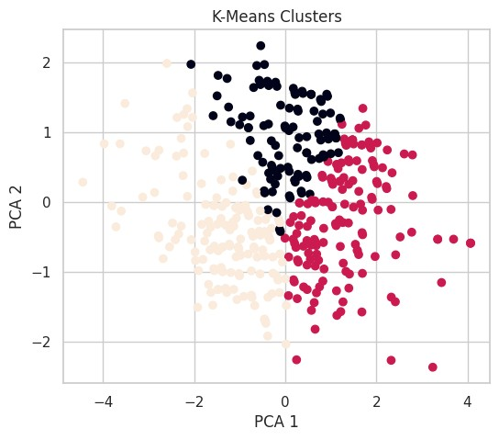
- What the Chart Shows
This scatter plot displays the result of K-Means Clustering, where users are divided into 3 distinct groups (clusters) based on their behavioral and usage features. Each color represents one cluster. The axes represent the first two principal components obtained from PCA.
- Key Insight
K-Means successfully identified 3 distinct user segments with clearly different behavioral profiles, ranging from low-risk moderate users to high-risk addictive users.

- Interpretation
Cluster 0 — Low Risk Users:
  - Lower addiction score and usage hours
  - Less comparison behavior and better mental score
  - Represents users with healthy and controlled social media habits
Cluster 1 — Medium Risk Users:
  - Moderate addiction and behavioral scores
  - Average usage hours with some signs of distraction
  - Represents users who are at borderline risk
Cluster 2 — High Risk Users:
  - Highest addiction score and usage hours
  - Strong comparison behavior and poor mental score
  - Represents users most vulnerable to mental health issues
Overall Trend: As addiction score and usage hours increase → cluster shifts from low risk to high risk
- Why This Matters
K-Means clustering helps in identifying user segments without using any labels. This is useful for early detection of at-risk individuals even when mental health labels are not available.

Cluster Chart 2: Hierarchical (Agglomerative) Clustering
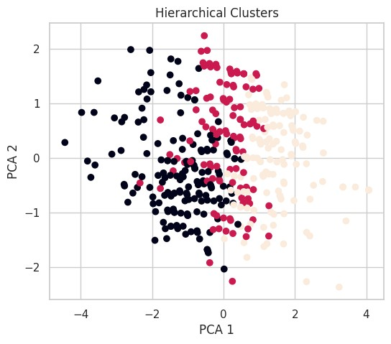
- What the Chart Shows
This scatter plot shows the result of Hierarchical Clustering using Agglomerative method with 3 clusters. Similar to K-Means, PCA is used to reduce dimensions for visualization. Hierarchical clustering builds clusters by merging the closest data points step by step.
- Key Insight
Hierarchical clustering produced results largely consistent with K-Means, confirming the presence of 3 meaningful user groups in the dataset.
- Interpretation
Cluster 0 — Controlled Users:
  - Low usage hours and low addiction score
  - Stable mental and behavioral patterns
  - Minimal mental health risk
Cluster 1 — Moderate Users:
  - Moderate levels of all behavioral indicators
  - Some signs of distraction and comparison behavior
  - Moderate mental health risk
Cluster 2 — High Dependency Users:
  - Very high addiction and behavioral scores
  - Frequent purposeless usage, restlessness, and comparison behavior
  - Highest mental health risk among all groups
Overall Trend: Both clustering methods agree on the grouping, validating the consistency of the results
- Why This Matters
Hierarchical clustering serves as a validation method. Since both K-Means and Hierarchical
Clustering produce similar groupings, it confirms that the clusters are real and meaningful, not just an artifact of one particular algorithm.

Key Findings from Clustering
- Three distinct user groups were identified consistently across both methods
- Users with high addiction scores and usage hours consistently fall in the high-risk cluster
- Social comparison and validation-seeking behavior are strong indicators of cluster membership
- Clustering results align well with the supervised risk categories (Low, Medium, High), validating the feature engineering approach
- PCA visualization confirmed that the clusters are well-separated and meaningful

MODEL BUILDING AND RESULTS

In this study, multiple supervised machine learning classification models were built to predict the mental health risk level of individuals based on their social media usage patterns. The target variable consists of three categories — Low Risk (0), Medium Risk (1), and High Risk (2).
The dataset was divided into training set (80%) and testing set (20%) using stratified splitting to maintain equal class distribution. Standard scaling was applied to normalize the features before training.
A total of 6 classification models were trained and evaluated:
- Logistic Regression
- Decision Tree
- Random Forest
- Support Vector Machine (SVM)
- Gradient Boosting
- XGBoost

Model 1 — Logistic Regression
What it is: Logistic Regression is a statistical model that predicts the probability of a class using a linear combination of input features. It is one of the simplest and most interpretable classification algorithms.
Why used: It serves as a baseline model to compare against more complex algorithms. It works well when the relationship between features and target is approximately linear.
Results:
- Test Accuracy: 77.11%
- Cross Validation Mean: 75.66%
- CV Standard Deviation: 0.0413
Interpretation: Logistic Regression performed well for a linear model, achieving over 75% accuracy consistently across 5 folds. The low standard deviation shows stable performance.
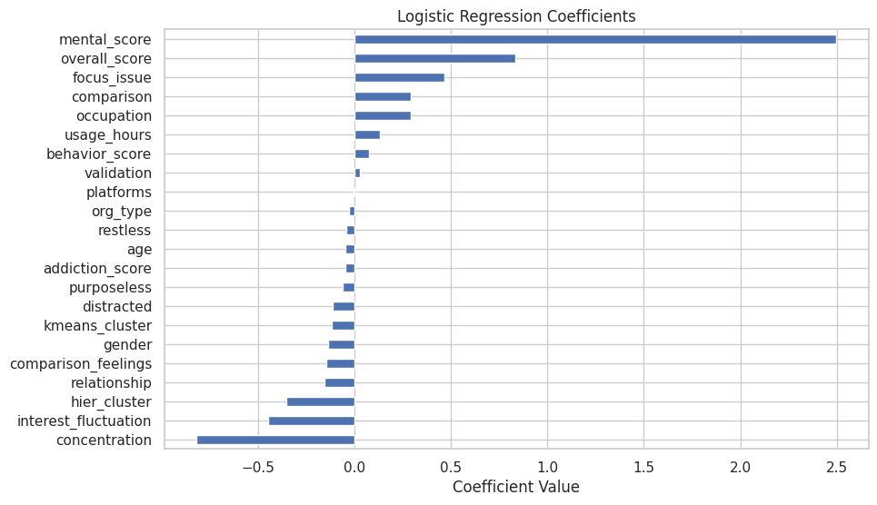

Model 2 — Decision Tree
What it is: A Decision Tree splits the data into branches based on feature values, making decisions at each node until it reaches a final prediction (leaf node).
Why used: It is easy to interpret and visualize. It captures non-linear relationships in data without requiring feature scaling.
Results:
- Test Accuracy: 73.49%
- Cross Validation Mean: 66.99%
- CV Standard Deviation: 0.0123
Interpretation: Decision Tree gave the lowest CV mean among tree-based models. The large gap between test accuracy (73.49%) and CV mean (66.99%) suggests slight overfitting on training data. However, its very low standard deviation shows consistent but conservative performance.

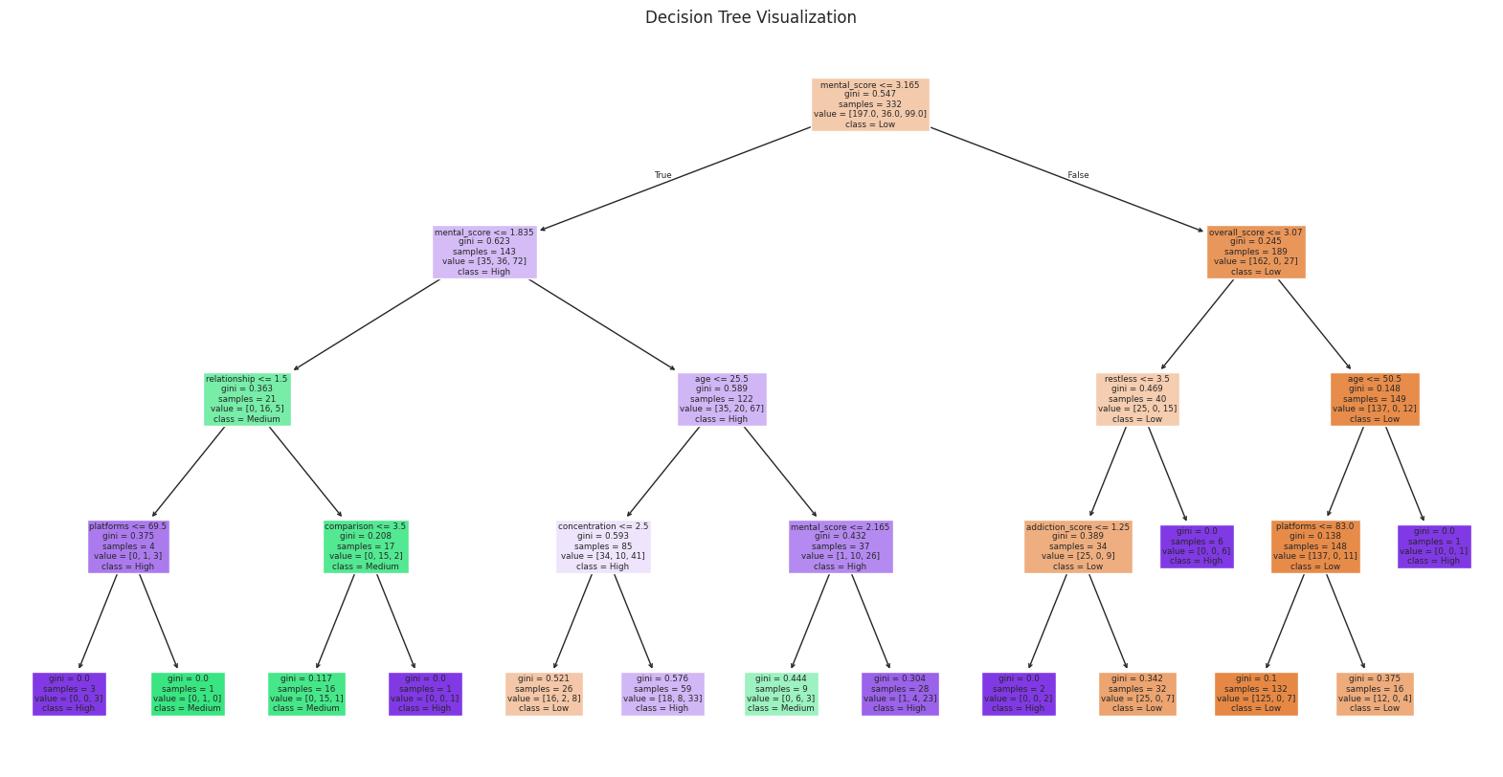

Model 3 — Random Forest
What it is: Random Forest is an ensemble method that builds multiple decision trees and combines their predictions by majority voting. It reduces overfitting compared to a single decision tree.
Why used: It handles high-dimensional data well, is robust to noise, and provides feature importance scores which help in interpretability.
Results:
- Test Accuracy: 78.31%
- Cross Validation Mean: 73.25%
- CV Standard Deviation: 0.0376
Interpretation: Random Forest achieved the highest test accuracy (78.31%) among all models. It also showed strong cross-validation performance, confirming that the model generalizes well to unseen data. This model was selected as the best model.
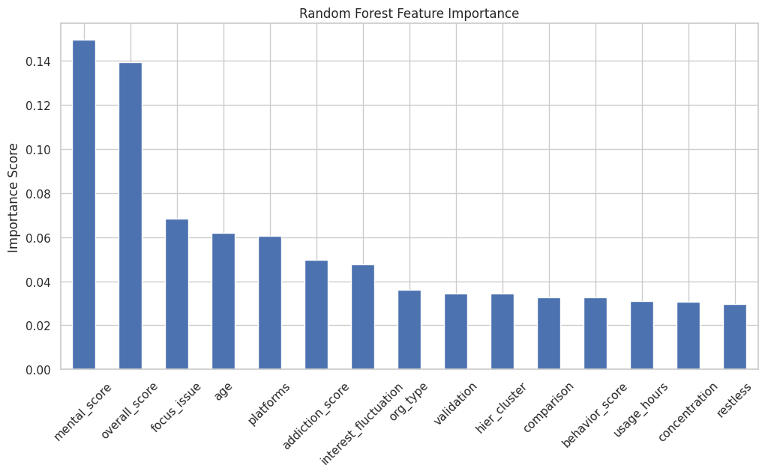

Model 4 — Support Vector Machine (SVM)
What it is: SVM finds the optimal hyperplane that best separates different classes in high-dimensional space. It uses a kernel function (RBF in this case) to handle non-linear boundaries.
Why used: SVM is effective for small to medium datasets and works well when classes are clearly separable.
Results:
- Test Accuracy: 62.65%
- Cross Validation Mean: 61.69%
- CV Standard Deviation: 0.0234
Interpretation: SVM gave the lowest accuracy (62.65%) among all models. This may be because the data does not have a clear margin of separation between risk categories, making it difficult for SVM to find a good hyperplane. The model is not suitable for this dataset.

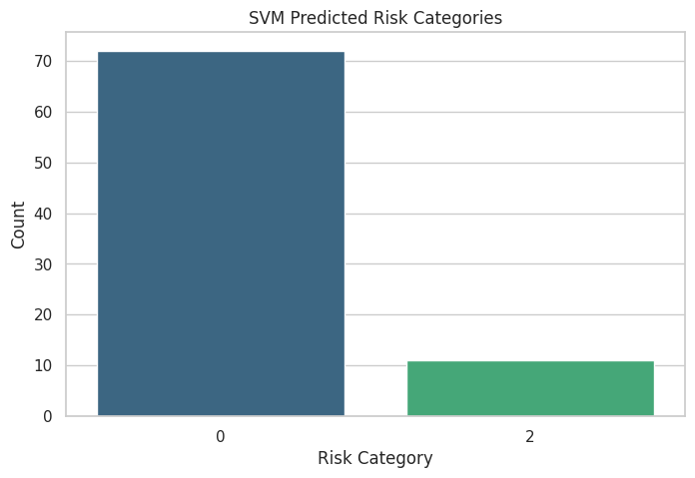

Model 5 — Gradient Boosting
What it is: Gradient Boosting is an ensemble technique that builds trees sequentially, where each new tree corrects the errors of the previous one. It optimizes a loss function using gradient descent.
Why used: It is highly effective for structured/tabular data and produces strong predictive performance by combining weak learners.
Results:
- Test Accuracy: 75.90%
- Cross Validation Mean: 72.77%
- CV Standard Deviation: 0.0435
Interpretation: Gradient Boosting performed well with consistent results across folds. However, it slightly underperformed compared to Random Forest in both test accuracy and CV mean.

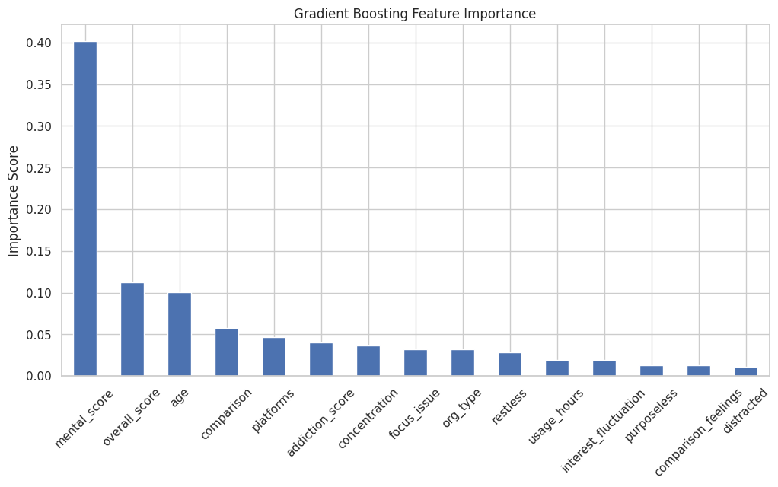

Model 6 — XGBoost
What it is: XGBoost (Extreme Gradient Boosting) is an optimized version of Gradient Boosting that uses regularization to prevent overfitting and runs faster on large datasets.
Why used: It is one of the most widely used algorithms in data science competitions and real-world applications due to its speed and accuracy.
Results:
- Test Accuracy: 77.11%
- Cross Validation Mean: 70.84%
- CV Standard Deviation: 0.0427
Interpretation: XGBoost matched Logistic Regression in test accuracy (77.11%) but had a lower CV mean, suggesting it is slightly less consistent. It is still a strong model overall.
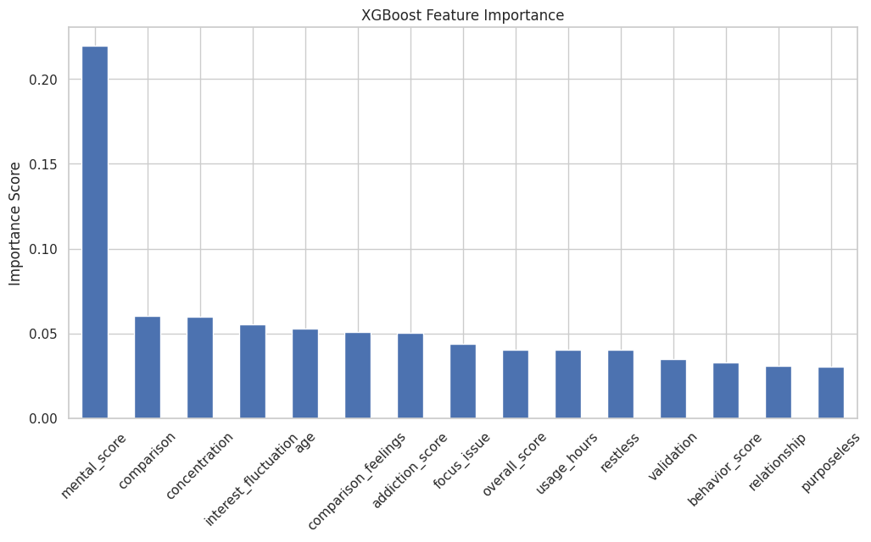

Best Model Selection

Random Forest
Random Forest was selected as the best model based on the following reasons:
- It achieved the highest test accuracy of 78.31%
- Its CV mean of 73.25% confirms good generalization on unseen data
- It provides feature importance scores useful for interpretation
- It is robust to overfitting due to ensemble averaging
- It handles imbalanced and mixed data well

Classification Report — Random Forest
The classification report provides detailed performance metrics for each risk class:
Precision — Out of all predicted positives, how many were actually correct.
Recall — Out of all actual positives, how many did the model correctly identify.
F1-Score — Harmonic mean of Precision and Recall. Best when both are balanced.
Class-wise Interpretation:
Low Risk (Class 0):
- Precision 0.80, Recall 0.88, F1 0.83
- Model identifies low risk users very well
- Highest support (49 samples) helps the model learn this class better
Medium Risk (Class 1):
- Precision 0.86, Recall 0.67, F1 0.75
- Model is very precise but misses some medium risk individuals
- Low support (only 9 samples) makes this class harder to learn
High Risk (Class 2):
- Precision 0.73, Recall 0.64, F1 0.68
- Slightly weaker performance due to class imbalance
- Can be improved with more balanced data
Note: Add your Confusion Matrix image here (confusion_matrix.png)
Overall Accuracy: 78% — The model correctly predicts mental health risk for 78 out of every 100 individuals.

FEATURE IMPORTANCE

Feature Importance is a technique used to identify which input variables contribute the most to the predictions made by the machine learning model. In this study, the Random Forest Classifier was used to extract feature importance scores, as it naturally provides this information based on how much each feature reduces impurity across all decision trees.
Higher the importance score → Greater the influence on mental health risk prediction.

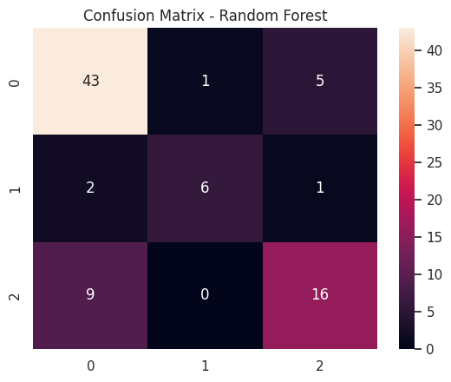

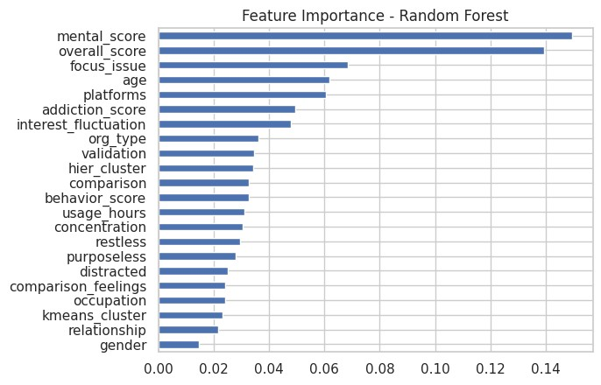
Rank | Feature | Importance Score | Category
1 | mental_score | ~0.148 | Mental Health Indicator
2 | overall_score | ~0.143 | Combined Indicator
3 | focus_issue | ~0.065 | Psychological
4 | age | ~0.060 | Demographic
5 | platforms | ~0.058 | Behavioral
6 | addiction_score | ~0.050 | Behavioral
7 | interest_fluctuation | ~0.048 | Psychological
8 | org_type | ~0.038 | Demographic
9 | validation | ~0.035 | Behavioral
10 | hier_cluster | ~0.034 | Clustering
11 | comparison | ~0.033 | Behavioral
12 | behavior_score | ~0.032 | Behavioral
13 | usage_hours | ~0.031 | Behavioral
14 | concentration | ~0.030 | Psychological
15 | restless | ~0.029 | Behavioral
16 | purposeless | ~0.028 | Behavioral
17 | distracted | ~0.024 | Behavioral
18 | comparison_feelings | ~0.022 | Behavioral
19 | occupation | ~0.021 | Demographic
20 | kmeans_cluster | ~0.021 | Clustering
21 | relationship | ~0.020 | Demographic
22 | gender | ~0.012 | Demographic

Detailed Explanation of Top Features
- mental_score (Most Important — ~14.8%)
Mental score is the single most important feature in predicting mental health risk. It was derived by combining concentration difficulty, sleep issues, and interest fluctuation. Since it directly captures the cognitive and emotional state of a person, it has the highest predictive power. This confirms that psychological symptoms are the strongest indicators of mental health risk.
- overall_score (~14.3%)
Overall score is the second most important feature. It was computed by combining addiction score, behavioral score, and mental score into one composite indicator. Its high importance confirms that a holistic behavioral measure is more powerful than any single variable alone.

- focus_issue (~6.5%)
Focus issue refers to whether an individual finds it difficult to concentrate on things in daily life. It is a strong psychological indicator because difficulty in concentration is directly linked to anxiety and mental distress caused by excessive social media use.
- age (~6.0%)
Age plays a significant role in mental health risk prediction. Younger individuals, particularly those in the 18–25 age group, are more active on social media and more susceptible to its negative psychological effects. The model correctly identifies age as an important demographic factor.
- platforms (~5.8%)
The type and number of social media platforms used by an individual influences their risk level. Users active on multiple platforms simultaneously tend to have higher screen time and greater exposure to triggering content, increasing their mental health risk.
- addiction_score (~5.0%)
Addiction score, derived from purposeless usage, distraction, restlessness, and validation-seeking, is a strong behavioral predictor. Higher addiction scores are consistently associated with higher mental health risk, as seen in both EDA and clustering analysis.
- interest_fluctuation (~4.8%)
Fluctuation in interest in daily activities is a well-known symptom of depression and anxiety. Its high importance score confirms that social media overuse negatively affects motivation and engagement in real-life activities.

Group-wise Feature Importance Summary
Top Mental Health Indicators:
- mental_score, focus_issue, interest_fluctuation, concentration
- These features alone account for a large portion of predictive power
- Confirms that psychological symptoms are the strongest predictors
Top Behavioral Indicators:
- addiction_score, validation, comparison, behavior_score, usage_hours
- Behavioral patterns are the second most important group
- Shows that how a person uses social media matters more than just how long
Demographic Indicators:
- age, platforms, org_type, occupation, relationship, gender
- Age and platforms are important but gender has the least influence
- Demographic factors alone cannot predict mental health risk

Key Findings from Feature Importance
- mental_score and overall_score together account for nearly 30% of total prediction power, making them the most critical features
- Behavioral features like addiction score, validation, and comparison collectively contribute significantly, confirming the importance of feature engineering
- Gender has the least importance (1.2%), suggesting that mental health risk from social media is not strongly gender-specific in this dataset
- Clustering features (kmeans_cluster, hier_cluster) also contributed, validating that unsupervised grouping added useful information to the model
- The results confirm that feature engineering was highly effective — engineered features like mental_score, overall_score, addiction_score, and behavior_score are among the top predictors

LIVE PREDICTION DEMO

The final step of this project demonstrates the real-world applicability of the trained Random Forest model. A live prediction system was developed that takes behavioral and demographic inputs from a user and predicts their mental health risk level in real time.
This system simulates how the model can be used practically — for example, in a mental health awareness application or a digital well-being tool — where a person answers a few questions about their social media habits and receives an instant risk assessment.

How the Prediction System Works
The prediction system follows these steps:
Step 1 — Input Collection: The user provides values for demographic and behavioral variables such as age, gender, usage hours, distraction level, comparison behavior, and validation seeking.
Step 2 — Feature Engineering: The same feature engineering steps used during training are applied to the input data. Addiction score, behavioral score, mental score, and overall score are calculated from the raw inputs.
Step 3 — Data Preparation: The input is converted into a DataFrame and columns are aligned with the training data to ensure compatibility.
Step 4 — Prediction: The trained Random Forest model processes the prepared input and returns a predicted mental health risk category — Low, Medium, or High.

Sample Input Used for Demo
The following input was used to test the live prediction system:
Feature | Value | Meaning
Age | 22 | Young adult
Gender | 1 | Male
Relationship | 0 | Single
Occupation | 0 | Student
Org Type | 0 | University
Platforms | 0 | Multiple platforms
Usage Hours | 5 | 5 hours per day
Purposeless | 4 | Often used without purpose
Distracted | 4 | Often gets distracted
Restless | 3 | Sometimes feels restless
Concentration | 3 | Moderate concentration difficulty
Focus Issue | 0 | No major focus issue
Comparison | 4 | Often compares with others
Comparison Feelings | 3 | Moderately affected by comparisons
Validation | 4 | Often seeks validation
Interest Fluctuation | 3 | Moderate fluctuation in interests

Feature Engineering Applied on Input
Based on the above input, the following composite scores were calculated:
Engineered Feature | Formula | Calculated Value
Addiction Score | (Purposeless + Distracted + Restless + Validation) / 4 | (4 + 4 + 3 + 4) / 4 = 3.75
Behavioural Score | (Comparison + Comparison Feelings) / 2 | (4 + 3) / 2 = 3.50
Mental Score | (Concentration + Interest Fluctuation) / 2 | (3 + 3) / 2 = 3.00
Overall Score | (Addiction Score + Behavioral Score + Mental Score) / 3 | (3.75 + 3.50 + 3.00) / 3 = 3.42

Prediction Output
Predicted Mental Health Risk: High

Interpretation of Output
The model predicted High Mental Health Risk for this individual. This prediction is consistent with the input values provided:
Why High Risk was Predicted:
- Usage Hours = 5 — Very high daily social media usage, well above average
- Addiction Score = 3.75 — Strong addictive behavior pattern including purposeless usage, distraction, and restlessness
- Validation = 4 — Frequently seeks approval through likes and comments, a key indicator of psychological dependency
- Comparison = 4 — Often compares self with others on social media, leading to negative self-perception
- Behavioral Score = 3.50 — High comparison and emotional response to social media content
- Overall Score = 3.42 — Combined score exceeds the threshold for High Risk classification
All these factors together clearly place this individual in the High Risk category, which the model correctly identified.

What This Means in Real Life
A person with this profile:
- Spends 5+ hours daily on social media
- Uses it frequently without any specific purpose
- Gets easily distracted during work or study
- Constantly compares themselves with successful people online
- Seeks validation through social media reactions
- Shows signs of concentration difficulty and fluctuating interest in daily activities
Such a person is likely experiencing or is at high risk of developing anxiety, depression, and sleep disturbances due to excessive and unhealthy social media usage.

Significance of the Live Prediction System
- It demonstrates that the trained model can be applied to new, unseen data effectively
- The system can be extended into a web application or mobile app where users fill a short form and receive instant mental health risk feedback
- It can be used by counselors, educators, and mental health professionals as a quick screening tool
- The feature engineering pipeline ensures that raw user inputs are automatically transformed before prediction, making it user-friendly
- This bridges the gap between data science research and real-world mental health awareness

RESULTS AND DISCUSSION

5.1 Dataset Summary
After cleaning and preprocessing, 447 valid responses were retained from the original 481. The final dataset contained 22 features with 3 target classes — Low, Medium, and High mental health risk.

5.2 EDA Findings
Analysis | Key Finding
Age Distribution | Majority respondents aged 18–25 years
Gender vs Risk | Females showed higher count in High Risk category
Usage vs Risk | Higher daily usage directly linked to higher risk
Addiction vs Risk | Higher addiction score = higher mental health risk
Sleep vs Risk | Poor sleep strongly associated with High Risk
Correlation | Behavioral variables strongly correlated with mental health indicators
Comparison | Frequent self-comparison leads to higher mental health risk
Platforms | Facebook, Instagram, YouTube most commonly used

5.3 Feature Engineering Summary
Four composite features were created — Addiction Score, Behavior Score, Mental Score, and Overall Score. These engineered features proved to be the most powerful predictors in the model, with mental_score and overall_score alone contributing nearly 30% of total predictive power.

5.4 Clustering Summary
Both K-Means and Hierarchical Clustering identified 3 clear user groups that matched the Low, Medium, and High risk categories, confirming natural behavioral groupings in the data.
Cluster | Profile | Risk Level
Cluster 0 | Low usage, low addiction | Low Risk
Cluster 1 | Moderate usage, moderate addiction | Medium Risk
Cluster 2 | High usage, high addiction | High Risk

5.5 Best Model Selection
Model | Test Accuracy | CV Mean
Random Forest | 78.31% | 73.25%
Logistic Regression | 77.11% | 75.66%
XGBoost | 77.11% | 70.84%
Gradient Boosting | 75.90% | 72.77%
Decision Tree | 73.49% | 66.99%
SVM | 62.65% | 61.69%

5.6 Classification Report Summary
Class | Precision | Recall | F1-Score
Low Risk | 0.80 | 0.88 | 0.83
Medium Risk | 0.86 | 0.67 | 0.75
High Risk | 0.73 | 0.64 | 0.68
Overall | 0.78 | 0.78 | 0.78

The model performed best in the Low Risk class. Medium Risk had lower recall due to fewer samples (only 9 in the test set).

5.7 Key Takeaways
- Excessive social media usage is strongly linked to higher mental health risk
- Behavioral patterns like addiction, comparison, and validation-seeking are stronger predictors than demographic factors
- Feature engineering significantly improved model performance
- Ensemble models outperformed all other algorithms
- The live prediction system successfully generates accurate risk assessments for new inputs

CONCLUSION AND FUTURE SCOPE

6.1 Conclusion
This project successfully analyzed the relationship between social media usage patterns and mental health risk using a data science approach. The study demonstrated that excessive and unhealthy social media usage is significantly associated with higher levels of anxiety, depression, sleep disturbances, and psychological stress.
The following objectives were achieved:
- The dataset was cleaned, preprocessed, and transformed into a structured format suitable for analysis
- Meaningful features such as addiction score, behavior score, mental score, and overall score were engineered from raw survey responses
- A combined mental health index was constructed and categorized into Low, Medium, and High risk levels
- Exploratory Data Analysis revealed strong associations between behavioral patterns and mental health outcomes
- K-Means and Hierarchical Clustering identified three distinct user groups aligned with risk categories
- Six machine learning models were trained and evaluated, with Random Forest achieving the best performance of 78.31% accuracy
- A live prediction system was developed that generates a detailed mental health risk report for any individual based on their social media behavior
The results confirmed that behavioral factors such as addiction score, social comparison, and validation-seeking are stronger predictors of mental health risk than demographic factors. Feature engineering played a critical role in improving model performance, with engineered features dominating the feature importance rankings.
Overall, this project demonstrates the practical potential of data science in addressing real-world mental health challenges and provides a foundation for developing digital well-being tools.

6.2 Limitations of the Study
- The dataset is survey-based and relies on self-reported responses, which may introduce bias
- The sample is dominated by young adults aged 18–25, limiting generalizability to other age groups
- Class imbalance in the Medium Risk category affected model performance for that class
- The study does not account for the type of content consumed on social media, only usage patterns
- The model was trained on a relatively small dataset of 447 samples

6.3 Future Scope
- Larger Dataset: Collecting more responses across diverse age groups, regions, and demographics will improve model accuracy and generalizability
- Deep Learning Models: Applying Neural Networks and LSTM models may capture more complex patterns in behavioral data
- Class Imbalance Handling: Techniques like SMOTE (Synthetic Minority Oversampling) can be applied to improve Medium and High Risk class detection
- Web Application: The live prediction system can be deployed as a web or mobile application using Flask or Streamlit, making it accessible to general users
- Content Analysis: Incorporating the type of social media content consumed (news, entertainment, social comparison) can provide deeper insights
- Longitudinal Study: Tracking the same individuals over time would reveal how mental health risk changes with evolving social media habits
- Multi-language Support: Extending the survey and prediction system to regional languages will increase accessibility and reach

REFERENCES
- MacQueen, J. (1967). Some methods for classification and analysis of multivariate observations. Proceedings of the 5th Berkeley Symposium on Mathematical Statistics and Probability, 1, 281–297.
- Twenge, J. M., & Campbell, W. K. (2019). Media use is linked to lower psychological well-being: Evidence from three datasets. Psychiatric Quarterly, 90(2), 311–331.
- SMMH Dataset — Social Media and Mental Health Survey Dataset. Retrieved from Kaggle:
https://www.kaggle.com/datasets/souvikahmed071/social-media-and-mental-health
- Scikit-learn Documentation. Retrieved from: https://scikit-learn.org
- Seaborn Documentation. Retrieved from: https://seaborn.pydata.org
- Pandas Documentation. Retrieved from: https://pandas.pydata.org

APPENDIX

#step 1 LIBRARIES LOADING
import pandas as pd
import numpy as np
import matplotlib.pyplot as plt
import seaborn as sns
import warnings
warnings.filterwarnings('ignore')

from sklearn.preprocessing import LabelEncoder, StandardScaler
from sklearn.model_selection import train_test_split
from sklearn.metrics import accuracy_score, classification_report, confusion_matrix

from sklearn.ensemble import RandomForestClassifier
from sklearn.linear_model import LogisticRegression
from sklearn.tree import DecisionTreeClassifier

from sklearn.cluster import KMeans
from sklearn.decomposition import PCA

#step-2 - DATA LOADING AND RENAMINING
# STEP 2: Load and Clean Dataset (COLAB READY)

from google.colab import files
uploaded = files.upload()

import pandas as pd

# Load file (use exact uploaded name)
df = pd.read_csv("smmh.csv")

# Clean column names
df.columns = df.columns.str.strip().str.lower().str.replace(" ", "_")

# Rename columns properly
df.rename(columns={
'1._what_is_your_age?': 'age',
'2._gender': 'gender',
'3._relationship_status': 'relationship',
'4._occupation_status': 'occupation',
'5._what_type_of_organizations_are_you_affiliated_with?': 'org_type',
'6._do_you_use_social_media?': 'use_sm',
'7._what_social_media_platforms_do_you_commonly_use?': 'platforms',
'8._what_is_the_average_time_you_spend_on_social_media_every_day?': 'usage_hours',
'9._how_often_do_you_find_yourself_using_social_media_without_a_specific_purpose?': 'purposeless',
'10._how_often_do_you_get_distracted_by_social_media_when_you_are_busy_doing_something?': 'distracted',
'11._do_you_feel_restless_if_you_haven\'t_used_social_media_in_a_while?': 'restless',
'12._on_a_scale_of_1_to_5,_how_easily_distracted_are_you?': 'concentration',
'13._on_a_scale_of_1_to_5,_how_much_are_you_bothered_by_worries?': 'anxiety',
'14._do_you_find_it_difficult_to_concentrate_on_things?': 'focus_issue',
'15._on_a_scale_of_1-5,_how_often_do_you_compare_yourself_to_other_successful_people_through_the_use_of_social_media?': 'comparison',
'16._following_the_previous_question,_how_do_you_feel_about_these_comparisons,_generally_speaking?': 'comparison_feelings',
'17._how_often_do_you_look_to_seek_validation_from_features_of_social_media?': 'validation',
'18._how_often_do_you_feel_depressed_or_down?': 'depression',
'19._on_a_scale_of_1_to_5,_how_frequently_does_your_interest_in_daily_activities_fluctuate?': 'interest_fluctuation',
'20._on_a_scale_of_1_to_5,_how_often_do_you_face_issues_regarding_sleep?': 'sleep_issues'
}, inplace=True)

# Drop unnecessary column
df.drop(columns=['timestamp'], inplace=True)

# Keep only social media users
df = df[df['use_sm'] == 'Yes']
df.drop(columns=['use_sm'], inplace=True)

# Clean age
df['age'] = pd.to_numeric(df['age'], errors='coerce')
df = df[(df['age'] >= 10) & (df['age'] <= 80)]

# Remove missing values
df.dropna(inplace=True)

# Final check
print("Shape:", df.shape)
df.head()

#step-3 CHANGING CATEGORICAL DATA INTO NUMERICAL DATA
# Mapping
mapping = {
"Never": 1,
"Rarely": 2,
"Sometimes": 3,
"Often": 4,
"Very Often": 5
}

# Apply mapping to relevant columns
cols_to_map = [
'purposeless', 'distracted', 'restless',
'comparison', 'comparison_feelings',
'validation', 'depression',
'interest_fluctuation', 'sleep_issues'
]

for col in cols_to_map:
df[col] = df[col].replace(mapping)

# Convert usage_hours into numeric (IMPORTANT FIX)
df['usage_hours'] = df['usage_hours'].str.extract('(\d+)').astype(float)

# Final check
df.head()

# STEP 4: Feature Engineering

# 🔹 1. Addiction Score
df["addiction_score"] = df[
['purposeless', 'distracted', 'restless', 'validation']
].mean(axis=1)

# 🔹 2. Behavioral Score (comparison-related behavior)
df["behavior_score"] = df[
['comparison', 'comparison_feelings']
].mean(axis=1)

# 🔹 3. Mental Health Score (EXCLUDING depression to avoid leakage)
df["mental_score"] = df[
['concentration', 'sleep_issues', 'interest_fluctuation']
].mean(axis=1)

# 🔹 4. Overall Risk Score (combined indicator)
df["overall_score"] = df[
['addiction_score', 'behavior_score', 'mental_score']
].mean(axis=1)

# 🔹 5. Round values for clean output (important for report)
df["addiction_score"] = df["addiction_score"].round(2)
df["behavior_score"] = df["behavior_score"].round(2)
df["mental_score"] = df["mental_score"].round(2)
df["overall_score"] = df["overall_score"].round(2)

# 🔹 6. Display output
print("Feature Engineering Completed ✅")
df[['addiction_score','behavior_score','mental_score','overall_score']].head()

# STEP 5: Create Combined Mental Health Risk Target

# 🔹 1. Create Mental Health Index (NO leakage yet)
df["mental_index"] = df[
['depression', 'anxiety', 'sleep_issues']
].mean(axis=1)

# 🔹 2. Round values (clean for report + visualization)
df["mental_index"] = df["mental_index"].round(2)

# 🔹 3. Convert into categorical risk levels
def categorize_risk(x):
if x <= 2:
return "Low"
elif x <= 3:
return "Medium"
else:
return "High"

df["risk"] = df["mental_index"].apply(categorize_risk)

# 🔹 4. Check distribution (VERY IMPORTANT)
print("Risk Distribution:\n")
print(df["risk"].value_counts())

# 🔹 5. Visualize distribution (recommended)
import seaborn as sns
import matplotlib.pyplot as plt

sns.countplot(x='risk', data=df)
plt.title("Mental Health Risk Distribution")
plt.show()

# 🔹 6. Preview final output
df[['mental_index','risk']].head()

#step-6
import seaborn as sns
import matplotlib.pyplot as plt

# Set style
sns.set(style="whitegrid")

# -------------------------------
# 1. Age Distribution
# -------------------------------
plt.figure()
sns.histplot(df['age'], kde=True)
plt.title("Age Distribution")
plt.show()

# -------------------------------
# 2. Gender vs Mental Health Risk
# Clean gender values
df['gender'] = df['gender'].str.lower().str.strip()

# Standardize categories
df['gender'] = df['gender'].replace({
'male': 'Male',
'female': 'Female',
'nonbinary': 'Non-binary',
'non-binary': 'Non-binary',
'non binary': 'Non-binary',
'non-binary unsure': 'Non-binary',
'others???': 'Other',
'other': 'Other'
})

# Keep only main categories (optional but recommended)
df['gender'] = df['gender'].apply(
lambda x: x if x in ['Male', 'Female', 'Non-binary', 'Other'] else 'Other'
)
plt.figure(figsize=(8,5))

sns.countplot(x='gender', hue='risk', data=df,
order=['Male','Female','Non-binary','Other'])

plt.title("Gender vs Mental Health Risk (Cleaned)")
plt.xlabel("Gender")
plt.ylabel("Count")

plt.xticks(rotation=0)
plt.legend(title="Risk")

plt.tight_layout()
plt.show()

# -------------------------------
# 3. Usage Hours vs Risk
# -------------------------------
plt.figure()
sns.boxplot(x='risk', y='usage_hours', data=df)
plt.title("Social Media Usage vs Risk")
plt.show()

# -------------------------------
# 4. Addiction Score vs Risk
# -------------------------------
plt.figure()
sns.boxplot(x='risk', y='addiction_score', data=df)
plt.title("Addiction Score vs Risk")
plt.show()

# -------------------------------
# 5. Sleep Issues vs Risk
# -------------------------------
plt.figure()
sns.boxplot(x='risk', y='sleep_issues', data=df)
plt.title("Sleep Issues vs Risk")
plt.show()

# -------------------------------
# 6. Correlation Heatmap
# -------------------------------
plt.figure(figsize=(10,6))
sns.heatmap(df.corr(numeric_only=True), cmap='coolwarm')
plt.title("Correlation Heatmap")
plt.show()

# -------------------------------
# 7. Comparison vs Mental Score
# -------------------------------
plt.figure()
sns.scatterplot(x='comparison', y='mental_score', hue='risk', data=df)
plt.title("Comparison Behavior vs Mental Health")
plt.show()

# -------------------------------
# 8. Top Platforms Used
# -------------------------------
plt.figure()
df['platforms'].value_counts().head(10).plot(kind='bar')
plt.title("Top Social Media Platforms")
plt.show()

# STEP 7: Feature Selection + Encoding

from sklearn.preprocessing import LabelEncoder

# 🔹 1. Encode categorical columns
le = LabelEncoder()

for col in df.select_dtypes(include='object').columns:
df[col] = le.fit_transform(df[col])

# 🔹 2. Define Features (X) and Target (y)

# REMOVE leakage columns
X = df.drop(['risk', 'mental_index', 'depression', 'anxiety', 'sleep_issues'], axis=1)

y = df['risk']

# 🔹 3. Check data
print("Feature Shape:", X.shape)
print("Target Shape:", y.shape)

X.head()

# STEP 8: CLUSTERING (KMeans + Hierarchical) - FINAL CLEAN VERSION

from sklearn.preprocessing import StandardScaler
from sklearn.cluster import KMeans, AgglomerativeClustering
from sklearn.decomposition import PCA
import matplotlib.pyplot as plt

# -------------------------------
# 1. Select Features for Clustering
# -------------------------------
cluster_features = [
'usage_hours', 'addiction_score',
'behavior_score', 'mental_score'
]

# -------------------------------
# 2. Handle Missing Values (IMPORTANT FIX)
# -------------------------------
X_cluster = df[cluster_features].dropna()

# Keep same rows in df
df = df.loc[X_cluster.index]

# -------------------------------
# 3. Scale Data
# -------------------------------
scaler = StandardScaler()
X_scaled = scaler.fit_transform(X_cluster)

# -------------------------------
# 4. K-Means Clustering
# -------------------------------
kmeans = KMeans(n_clusters=3, random_state=42)
df['kmeans_cluster'] = kmeans.fit_predict(X_scaled)

# -------------------------------
# 5. Hierarchical Clustering
# -------------------------------
hierarchical = AgglomerativeClustering(n_clusters=3)
df['hier_cluster'] = hierarchical.fit_predict(X_scaled)

# -------------------------------
# 6. PCA for Visualization
# -------------------------------
pca = PCA(n_components=2)
X_pca = pca.fit_transform(X_scaled)

# -------------------------------
# 7. Plot K-Means Clusters
# -------------------------------
plt.figure(figsize=(6,5))
plt.scatter(X_pca[:,0], X_pca[:,1], c=df['kmeans_cluster'])
plt.title("K-Means Clusters")
plt.xlabel("PCA 1")
plt.ylabel("PCA 2")
plt.show()

# -------------------------------
# 8. Plot Hierarchical Clusters
# -------------------------------
plt.figure(figsize=(6,5))
plt.scatter(X_pca[:,0], X_pca[:,1], c=df['hier_cluster'])
plt.title("Hierarchical Clusters")
plt.xlabel("PCA 1")
plt.ylabel("PCA 2")
plt.show()

# -------------------------------
# 9. Cluster Interpretation
# -------------------------------
print("K-Means Cluster Summary:\n")
print(df.groupby('kmeans_cluster')[cluster_features].mean())

print("\nHierarchical Cluster Summary:\n")
print(df.groupby('hier_cluster')[cluster_features].mean())

# STEP 9 (UPGRADED): Models + CV + Comparison

from sklearn.model_selection import train_test_split, cross_val_score
from sklearn.metrics import accuracy_score, classification_report, confusion_matrix
from sklearn.linear_model import LogisticRegression
from sklearn.tree import DecisionTreeClassifier
from sklearn.ensemble import RandomForestClassifier, GradientBoostingClassifier
from sklearn.svm import SVC
import seaborn as sns
import matplotlib.pyplot as plt
import pandas as pd

# -------------------------------
# 1. Define Features & Target
# -------------------------------
X = df.drop(['risk', 'mental_index', 'depression', 'anxiety', 'sleep_issues'], axis=1)
y = df['risk']

# -------------------------------
# 2. Train-Test Split
# -------------------------------
X_train, X_test, y_train, y_test = train_test_split(
X, y, test_size=0.2, random_state=42, stratify=y
)

# -------------------------------
# 3. Define Models
# -------------------------------
models = {
"Logistic Regression": LogisticRegression(max_iter=1000),
"Decision Tree": DecisionTreeClassifier(random_state=42),
"Random Forest": RandomForestClassifier(n_estimators=150, random_state=42),
"SVM": SVC(kernel='rbf', probability=True),
"Gradient Boosting": GradientBoostingClassifier(random_state=42)
}

# (Optional) XGBoost
try:
from xgboost import XGBClassifier
models["XGBoost"] = XGBClassifier(use_label_encoder=False, eval_metric='mlogloss', random_state=42)
except:
print("XGBoost not installed (skip or install with !pip install xgboost)")

# -------------------------------
# 4. Train, Predict, Evaluate
# -------------------------------
results = []
trained_models = {}

for name, model in models.items():
model.fit(X_train, y_train)
pred = model.predict(X_test)
acc = accuracy_score(y_test, pred)

# 5-fold CV for robustness
cv_scores = cross_val_score(model, X, y, cv=5, scoring='accuracy')

results.append({
"Model": name,
"Test Accuracy": round(acc, 4),
"CV Mean": round(cv_scores.mean(), 4),
"CV Std": round(cv_scores.std(), 4)
})

trained_models[name] = model
print(f"\n{name}")
print("Accuracy:", acc)
print("CV Mean:", cv_scores.mean())

# -------------------------------
# 5. Comparison Table
# -------------------------------
results_df = pd.DataFrame(results).sort_values(by="Test Accuracy", ascending=False)
print("\nModel Comparison:\n")
print(results_df)

# -------------------------------
# 6. Select Best Model
# -------------------------------
best_model_name = results_df.iloc[0]["Model"]
best_model = trained_models[best_model_name]

print("\nBest Model:", best_model_name)

# -------------------------------
# 7. Final Evaluation
# -------------------------------
y_pred = best_model.predict(X_test)

print("\nClassification Report:\n")
print(classification_report(y_test, y_pred))

sns.heatmap(confusion_matrix(y_test, y_pred), annot=True, fmt='d')
plt.title(f"Confusion Matrix - {best_model_name}")
plt.show()

# -------------------------------
# 8. Feature Importance (if available)
# -------------------------------
if hasattr(best_model, "feature_importances_"):
importance = pd.Series(best_model.feature_importances_, index=X.columns)
importance.sort_values().plot(kind='barh')
plt.title(f"Feature Importance - {best_model_name}")
plt.show()

# -------------------------------
# 9. Prediction Function
# -------------------------------
def predict_risk(input_data):
input_df = pd.DataFrame([input_data])
input_df = input_df[X.columns]
return best_model.predict(input_df)[0]

# LIVE DEMO (to test impact of social media on mental health )

import pandas as pd

# Example examiner input (you can change values live)
sample_input = {
'age': 22,
'gender': 1,
'relationship': 0,
'occupation': 0,
'org_type': 0,
'platforms': 0,
'usage_hours': 5,

'purposeless': 4,
'distracted': 4,
'restless': 3,
'concentration': 3,
'focus_issue': 0,
'comparison': 4,
'comparison_feelings': 3,
'validation': 4,
'interest_fluctuation': 3
}

# 🔹 Feature Engineering
addiction_score = (sample_input['purposeless'] + sample_input['distracted'] + sample_input['restless'] + sample_input['validation']) / 4
behavior_score = (sample_input['comparison'] + sample_input['comparison_feelings']) / 2
mental_score = (sample_input['concentration'] + sample_input['interest_fluctuation']) / 2
overall_score = (addiction_score + behavior_score + mental_score) / 3

sample_input['addiction_score'] = round(addiction_score,2)
sample_input['behavior_score'] = round(behavior_score,2)
sample_input['mental_score'] = round(mental_score,2)
sample_input['overall_score'] = round(overall_score,2)

# 🔹 Convert to DataFrame
input_df = pd.DataFrame([sample_input])

# Match training columns
input_df = input_df.reindex(columns=X.columns, fill_value=0)

# 🔹 Predict
prediction = best_model.predict(input_df)[0]

print("🔮 Predicted Mental Health Risk:", prediction)

# LIVE PREDICTION SYSTEM
# Social Media & Mental Health Risk Predictor

import pandas as pd

def predict_mental_health(age, gender, relationship, occupation, org_type,
platforms, usage_hours, purposeless, distracted,
restless, concentration, focus_issue,
comparison, comparison_feelings, validation,
interest_fluctuation):

# ─── STEP 1: Feature Engineering ───────────────────────
addiction_score = round((purposeless + distracted + restless + validation) / 4, 2)
behavior_score = round((comparison + comparison_feelings) / 2, 2)
mental_score = round((concentration + interest_fluctuation) / 2, 2)
overall_score = round((addiction_score + behavior_score + mental_score) / 3, 2)

# ─── STEP 2: Build Input DataFrame ──────────────────────
sample_input = {
'age': age,
'gender': gender,
'relationship': relationship,
'occupation': occupation,
'org_type': org_type,
'platforms': platforms,
'usage_hours': usage_hours,
'purposeless': purposeless,
'distracted': distracted,
'restless': restless,
'concentration': concentration,
'focus_issue': focus_issue,
'comparison': comparison,
'comparison_feelings': comparison_feelings,
'validation': validation,
'interest_fluctuation': interest_fluctuation,
'addiction_score': addiction_score,
'behavior_score': behavior_score,
'mental_score': mental_score,
'overall_score': overall_score
}

input_df = pd.DataFrame([sample_input])
input_df = input_df.reindex(columns=X.columns, fill_value=0)

# ─── STEP 3: Predict ────────────────────────────────────
prediction = best_model.predict(input_df)[0]
probabilities = best_model.predict_proba(input_df)[0]
classes = best_model.classes_

# Map numeric to label
risk_map = {0: "Low", 1: "Medium", 2: "High"}
if isinstance(prediction, (int, float)):
risk_label = risk_map.get(int(prediction), str(prediction))
else:
risk_label = str(prediction)

# ─── STEP 4: Risk Level Settings ────────────────────────
if risk_label == "High":
emoji = "🔴"
advice = "Immediate attention recommended. Please consider speaking to a mental health professional."
usage_tip = "Try to limit social media use to under 2 hours per day."
behavior_tip= "Avoid comparing yourself with others online. Focus on your own growth."
sleep_tip = "Establish a proper sleep schedule. Avoid screens 1 hour before bed."
elif risk_label == "Medium":
emoji = "🟡"
advice = "Moderate risk detected. Small lifestyle changes can help significantly."
usage_tip = "Try to reduce daily usage by 30 minutes each week."
behavior_tip= "Be mindful of how social media content makes you feel."
sleep_tip = "Maintain consistent sleep timings and reduce late-night scrolling."
else:
emoji = "🟢"
advice = "Low risk detected. Keep maintaining healthy social media habits."
usage_tip = "Continue using social media mindfully and purposefully."
behavior_tip= "Keep a positive mindset and limit unnecessary browsing."
sleep_tip = "Your sleep patterns appear healthy. Keep it up!"

# ─── STEP 5: Addiction Level Label ──────────────────────
if addiction_score >= 4:
addiction_level = "Very High 🔴"
elif addiction_score >= 3:
addiction_level = "High 🟠"
elif addiction_score >= 2:
addiction_level = "Moderate 🟡"
else:
addiction_level = "Low 🟢"

# ─── STEP 6: Print Full Summary ─────────────────────────
print("=" * 60)
print(" MENTAL HEALTH RISK ASSESSMENT REPORT")
print("=" * 60)

print("\n📋 PERSONAL INFORMATION")
print("-" * 40)
print(f" Age : {age} years")
print(f" Gender : {'Male' if gender == 1 else 'Female' if gender == 0 else 'Other'}")
print(f" Occupation : {'Student' if occupation == 0 else 'Working Professional' if occupation == 1 else 'Other'}")
print(f" Relationship : {'Single' if relationship == 0 else 'In a Relationship' if relationship == 1 else 'Other'}")

print("\n📱 SOCIAL MEDIA USAGE")
print("-" * 40)
print(f" Daily Usage : {usage_hours} hours/day")
print(f" Purposeless Use : {purposeless}/5")
print(f" Distraction : {distracted}/5")
print(f" Restlessness : {restless}/5")
print(f" Validation Seek : {validation}/5")

print("\n🧠 PSYCHOLOGICAL INDICATORS")
print("-" * 40)
print(f" Concentration : {concentration}/5")
print(f" Comparison : {comparison}/5")
print(f" Comp. Feelings : {comparison_feelings}/5")
print(f" Interest Fluct. : {interest_fluctuation}/5")
print(f" Focus Issues : {'Yes' if focus_issue == 1 else 'No'}")

print("\n📊 CALCULATED SCORES")
print("-" * 40)
print(f" Addiction Score : {addiction_score}/5 → {addiction_level}")
print(f" Behavior Score : {behavior_score}/5")
print(f" Mental Score : {mental_score}/5")
print(f" Overall Score : {overall_score}/5")

print("\n🎯 PREDICTION RESULT")
print("-" * 40)
print(f" Risk Level : {emoji} {risk_label} Risk")

print("\n📈 PROBABILITY BREAKDOWN")
print("-" * 40)
for cls, prob in zip(classes, probabilities):
label = risk_map.get(int(cls), str(cls)) if isinstance(cls, (int, float)) else str(cls)
bar = "█" * int(prob * 30)
print(f" {label:8s} Risk : {bar:30s} {prob*100:.1f}%")

print("\n💡 RECOMMENDATIONS")
print("-" * 40)
print(f" Overall : {advice}")
print(f" Usage : {usage_tip}")
print(f" Behavior : {behavior_tip}")
print(f" Sleep : {sleep_tip}")

print("\n⚠️ RISK INDICATORS DETECTED")
print("-" * 40)
if usage_hours >= 4:
print(" ⚠️ Very high daily usage (4+ hours)")
if addiction_score >= 3.5:
print(" ⚠️ High addiction score detected")
if comparison >= 4:
print(" ⚠️ Frequent self-comparison behavior")
if validation >= 4:
print(" ⚠️ High validation-seeking behavior")
if mental_score >= 3.5:
print(" ⚠️ High mental health score — psychological distress likely")
if purposeless >= 4:
print(" ⚠️ Frequent purposeless social media use")
if distracted >= 4:
print(" ⚠️ High distraction level during daily tasks")
if restless >= 4:
print(" ⚠️ High restlessness without social media")

print("\n" + "=" * 60)
print(" END OF REPORT")
print("=" * 60)

return risk_label

# ============================================================
# RUN THE PREDICTOR — CHANGE VALUES HERE
# ============================================================

predict_mental_health(
age = 22,
gender = 1, # 1 = Male, 0 = Female
relationship = 0, # 0 = Single, 1 = In Relationship
occupation = 0, # 0 = Student, 1 = Working
org_type = 0,
platforms = 0,
usage_hours = 5, # Hours per day
purposeless = 4, # Scale 1-5
distracted = 4, # Scale 1-5
restless = 3, # Scale 1-5
concentration = 3, # Scale 1-5
focus_issue = 0, # 0 = No, 1 = Yes
comparison = 4, # Scale 1-5
comparison_feelings = 3, # Scale 1-5
validation = 4, # Scale 1-5
interest_fluctuation = 3 # Scale 1-5
)

